# Calculations with .groupby()

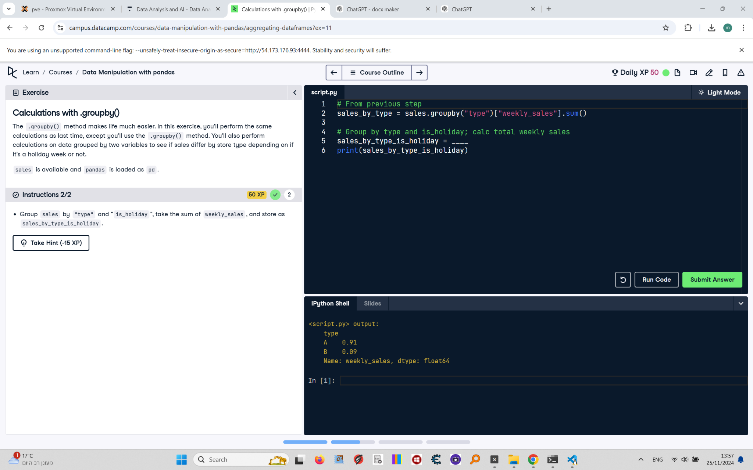

The .groupby() method makes life much easier. In this exercise, you'll perform the same calculations as last time, except you'll use the .groupby() method. You'll also perform calculations on data grouped by two variables to see if sales differ by store type depending on if it's a holiday week or not.  
  
sales is available and pandas is loaded as pd.

## Final Answer

# From previous step  
sales_by_type = sales.groupby("type")["weekly_sales"].sum()  
  
# Group by type and is_holiday; calc total weekly sales  
sales_by_type_is_holiday = sales.groupby(["type", "is_holiday"])["weekly_sales"].sum()  
print(sales_by_type_is_holiday)